|  |  |
| --- | --- |
| **相关样本肯德尔协同系数摘要** | |
| 总计 N | 10 |
| 肯德尔 W | .319 |
| 检验统计 | 86.219 |
| 自由度 | 27 |
| 渐进显著性（双侧检验） | .000 |

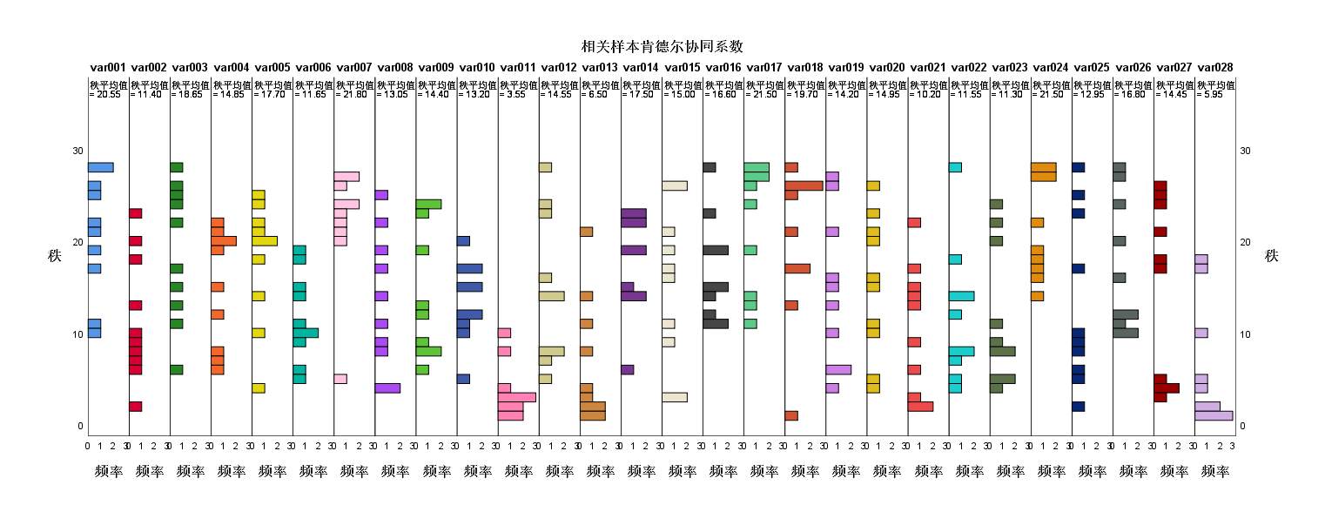

代码

GET DATA

/TYPE=XLSX

/FILE='D:\Adata\code\python\2012A\score.xlsx'

/SHEET=name '第一组白酒'

/CELLRANGE=FULL

/READNAMES=ON

/DATATYPEMIN PERCENTAGE=95.0

/HIDDEN IGNORE=YES.

EXECUTE.

DATASET NAME 数据集6 WINDOW=FRONT.

FLIP VARIABLES=@1 @2 @3 @4 @5 @6 @7 @8 @9 @10.

FLIP performed on 28 cases and 10 variables, creating 10 cases

and 29 variables. The working file has been replaced.

A new variable has been created called CASE_LBL. Its

contents are the old variable names.

New variable names:

CASE_LBL var001 var002 var003 var004 var005 var006 var007 var008 var009 var010

var011 var012 var013 var014 var015 var016 var017 var018 var019 var020 var021

var022 var023 var024 var025 var026 var027 var028

DATASET NAME 数据集7 WINDOW=FRONT.

EXECUTE.

*Nonparametric Tests: Related Samples.

NPTESTS

/RELATED TEST(var001 var002 var003 var004 var005 var006 var007 var008 var009 var010 var011 var012 var013 var014 var015 var016 var017 var018 var019 var020 var021 var022 var023 var024 var025 var026 var027 var028) KENDALL(COMPARE=PAIRWISE)

/MISSING SCOPE=ANALYSIS USERMISSING=EXCLUDE

/CRITERIA ALPHA=0.05 CILEVEL=95.